Activity 1

Look carefully at the picture and write in the table below the parts of the computer system.

**1**

**2**

**3**

**4**

**5**

**6**

**7**

**8**

**9**

**10**

**11**

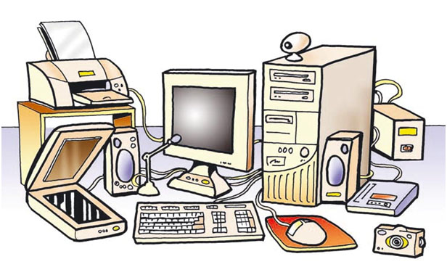

Parts of the computer system:

|  |  |
| --- | --- |
| **1** |  |
| **2** |  |
| **3** |  |
| **4** |  |
| **5** |  |
| **6** |  |
| **7** |  |
| **8** |  |
| **9** |  |
| **10** |  |
| **11** |  |

Activity 2

Classify the following devices into input and output devices, put a red X on the correct answer.

|  |  |  |
| --- | --- | --- |
| **DEVICE** | **INPUT** | **OUTPUT** |
| MONITOR |  |  |
| KEYBOARD |  |  |
| MOUSE |  |  |
| SPEAKERS |  |  |
| TOUCH SCREEN |  |  |
| MICROPHONE |  |  |
| DIGITAL CAMERA |  |  |
| SCANNER |  |  |
| PRINTER |  |  |