LESSON 23-02-2023 (PC PARTS)
Activity 1
Fill in the components you recognize based on the image below.
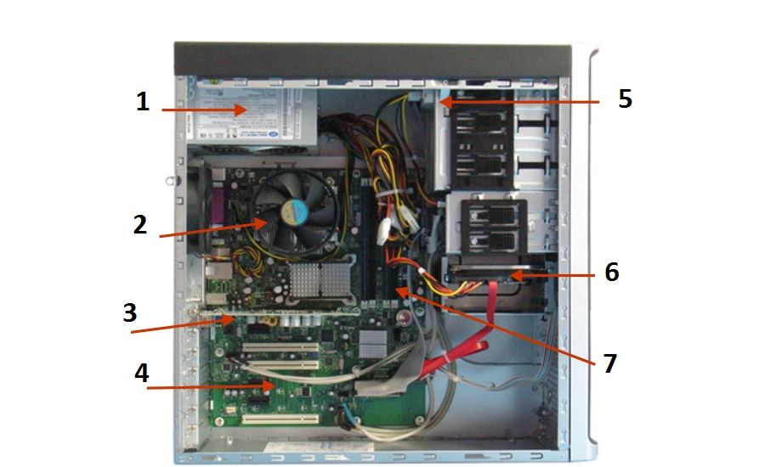

1
2
3
4
5
6
7

Activity 2
Fill in the connection ports you recognize based on the image below.

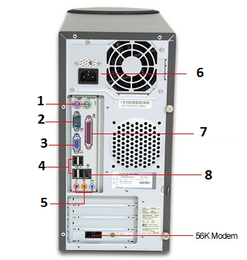

1
2
3
4
5
6
7
8

