Activity 1

Look carefully at the picture and write in the table below the parts of the computer system.

**1**

**2**

**3**

**4**

**5**

**6**

**7**

**8**

**9**

**10**

**11**

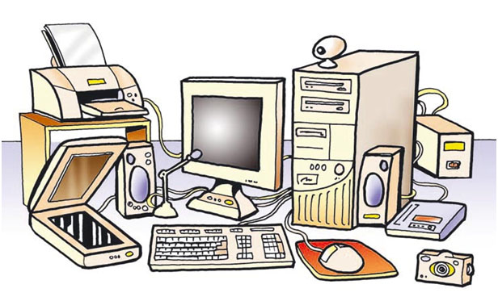

Parts of the computer system:

|  |  |
| --- | --- |
| **1** | TOWER |
| **2** | MONITOR |
| **3** | KEYBOARD |
| **4** | MOUSE |
| **5** | SPEAKERS |
| **6** | SCANNER |
| **7** | PRINTER |
| **8** | UPS(UNINTERRUPTIBLE POWER SUPPLY) |
| **9** | ROUTER |
| **10** | DIGITAL CAMERA |
| **11** | MICROPHONE |

Activity 2

Classify the following devices into input and output devices, put a red X on the correct answer.

|  |  |  |
| --- | --- | --- |
| **DEVICE** | **INPUT** | **OUTPUT** |
| MONITOR |  | **X** |
| KEYBOARD | **X** |  |
| MOUSE | **X** |  |
| SPEAKERS |  | **X** |
| TOUCH SCREEN | **X** | **X** |
| MICROPHONE | **X** |  |
| DIGITAL CAMERA | **X** | **X** |
| SCANNER | **X** |  |
| PRINTER |  | **X** |